Optimal Risky Portfolio (ORP)

Meaning
The Optimal Risky Portfolio is the best combination of risky assets that provides the highest possible return per unit of risk.
It is the portfolio that gives the maximum Sharpe Ratio.

✅ Definition
The Optimal Risky Portfolio is the portfolio of risky securities that lies on the efficient frontier and offers the highest excess return over the risk-free rate relative to its total risk.

✅ Key Features

1. Best Risk–Return Trade-off
It provides the most efficient balance between:
- Expected return
- Portfolio risk (standard deviation)

2. Maximum Sharpe Ratio
The ORP is selected because it has the:
Sharpe Ratio=(Rp−Rf)/σp
Where:
- Rp​ = Return on portfolio
- Rf = Risk-free rate
- σp​ = Portfolio risk

3. Tangency Portfolio
It is also called the Tangency Portfolio because it is the point where the:
- Capital Allocation Line (CAL) touches the Efficient Frontier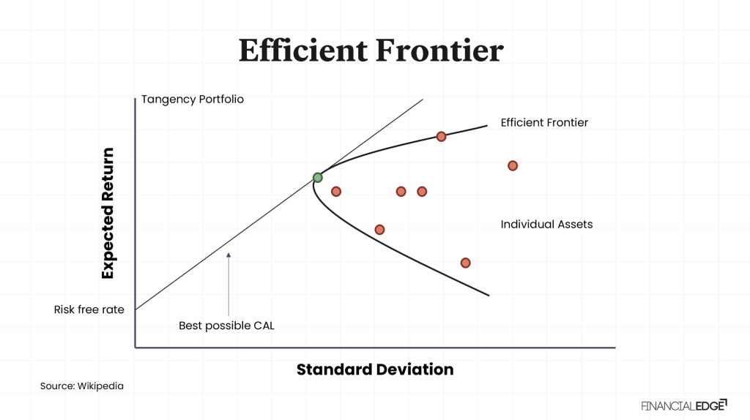

4. Consists Only of Risky Assets
It includes assets like:
- Equity shares
- Mutual funds
- Corporate bonds
- Market securities
(No risk-free asset is included inside it.)

✅ Graphical Representation
- Efficient Frontier shows best risky portfolios
- Risk-free asset gives a straight CAL
- ORP is the tangency point
📌 ORP lies at the highest point of CAL.
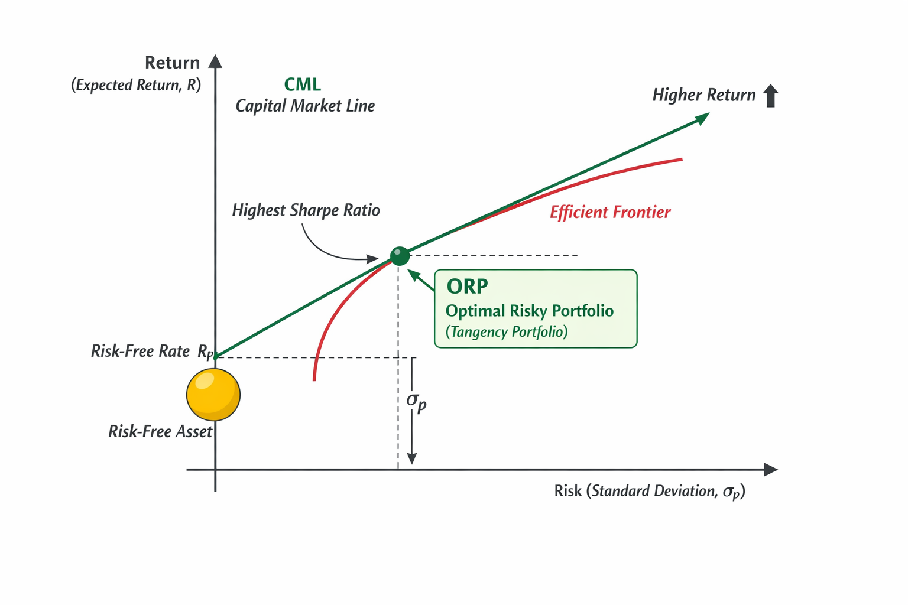

✅ Importance of Optimal Risky Portfolio

1. Provides the Best Risk–Return Combination
The ORP ensures that investors get the highest possible return for the amount of risk they are willing to take.
- It avoids unnecessary risk.
- It selects only the most efficient portfolio from all risky portfolios.
📌 Thus, ORP represents the best trade-off between risk and return.

2. Maximizes the Sharpe Ratio
The Optimal Risky Portfolio is selected because it has the maximum Sharpe Ratio, meaning:
Sharpe Ratio=(Rp−Rf)/σp
Where:
- Rp​ = Return on portfolio
- Rf = Risk-free rate
- σp​ = Portfolio risk
📌 ORP gives the maximum excess return per unit of total risk.
This makes it the most attractive risky portfolio for investors.

3. Helps Investors Combine Risky and Risk-Free Assets
Once ORP is identified, investors can construct their complete portfolio by mixing:
- Risk-free asset (Treasury bills)
- Optimal risky portfolio
This helps investors choose portfolios according to their risk tolerance:
- Conservative investors invest more in risk-free assets.
- Aggressive investors invest more in ORP.
📌 ORP is the foundation for building the best overall investment portfolio.

4. Lies on the Efficient Frontier
The efficient frontier contains portfolios that offer:
- Maximum return for a given risk level
ORP lies on the efficient frontier and is the most efficient portfolio among all risky portfolios.
📌 Investors avoid inefficient portfolios that provide lower return for the same risk.

5. Forms the Basis of the Capital Market Line (CML)
The Capital Market Line is drawn from:
- Risk-free rate
- Tangency point on efficient frontier (ORP)
Thus, ORP becomes the tangency portfolio that defines the CML.
📌 This is a key concept in Capital Market Theory.

6. Useful for Portfolio Diversification
ORP is created using multiple risky assets such as:
- Stocks
- Bonds
- Mutual funds
It ensures proper diversification, which:
- Reduces unsystematic risk
- Improves portfolio stability
📌 ORP helps investors achieve diversification benefits efficiently.

7. Guides Mutual Fund and Investment Managers
Fund managers aim to design portfolios close to the ORP because:
- It gives the best risk-adjusted return
- It attracts investors seeking optimal performance
📌 ORP is widely used in professional portfolio management.

8. Helps in Rational Decision Making
Instead of choosing assets randomly, ORP provides a scientific method to:
- Evaluate risk and return
- Select the most efficient portfolio
📌 It supports systematic and logical investment decisions.

9. Investor Utility Maximization
Different investors have different risk preferences.
ORP helps investors maximize their satisfaction (utility) by choosing the best mix of:
- Risk-free investment
- Risky investment
📌 Investors can reach their highest possible utility level using ORP.

10. Foundation for Modern Investment Theory
The ORP concept is central to:
- CAPM (Capital Asset Pricing Model)
- Portfolio optimization
- Risk-adjusted performance evaluation
📌 Without ORP, modern finance theories cannot be applied effectively.

✅ Example
Suppose two portfolios:
Portfolio | Return | Risk | Sharpe Ratio
A | 12% | 10% | 0.6
B | 15% | 12% | 0.75
📌 Portfolio B has a higher Sharpe Ratio → It is closer to the Optimal Risky Portfolio.

✅ Conclusion
The Optimal Risky Portfolio is the portfolio of risky assets that provides the maximum reward per unit of risk and is the foundation for combining risky investments with a risk-free asset.

